
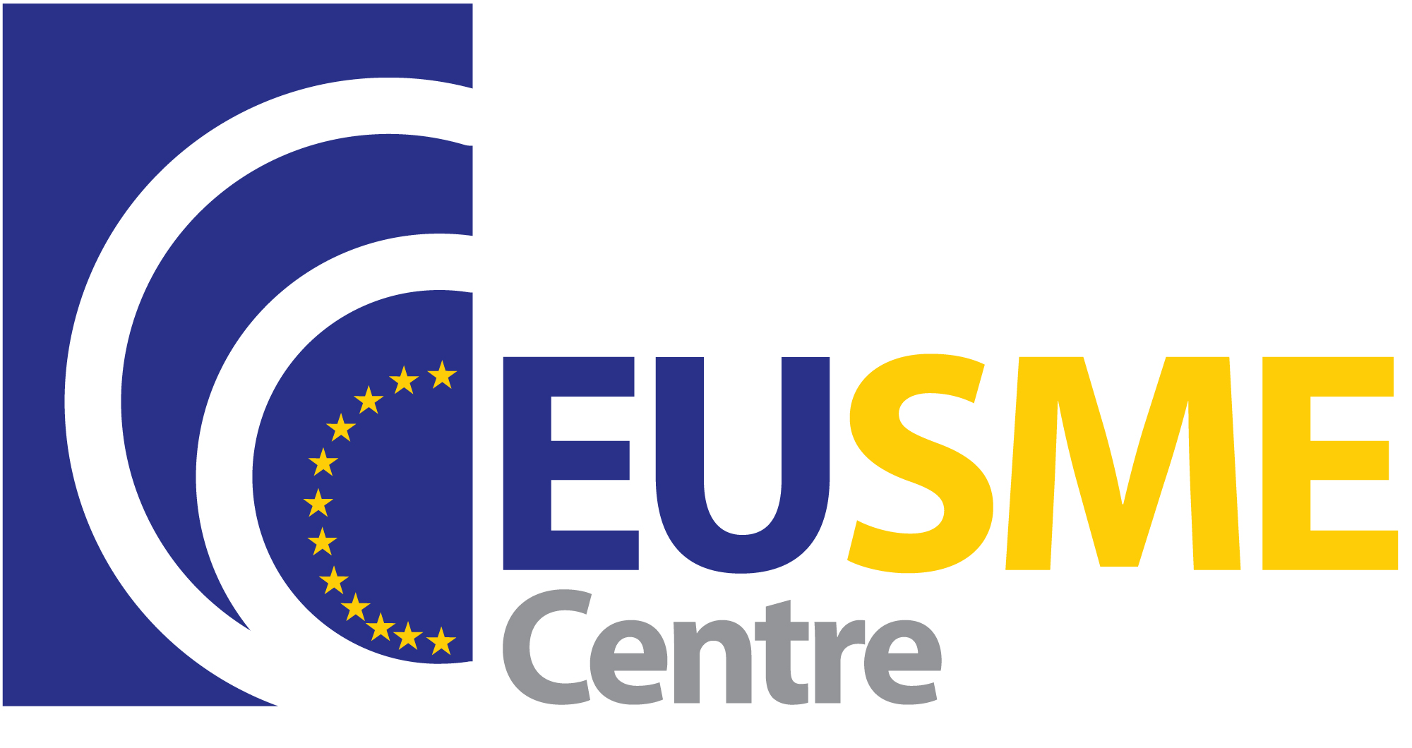


WORKSHOP: “Business Opportunities in Hong Kong & China”

organized by
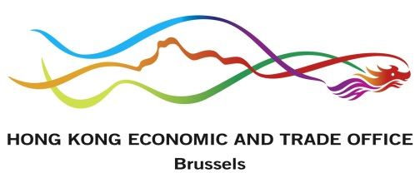
SEV Business Council for International Activities
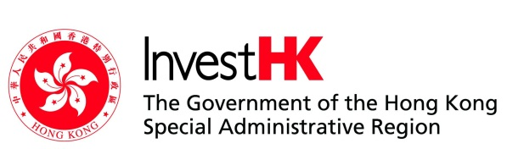
in cooperation with
Hellenic-Chinese Chamber
with the support of
Hong Kong Trade Development Council HKTDC
Hong Kong Economic and Trade Office, Brussels
InvestHK
EU SME Centre in China

Thursday, January 9th, 2014
SEV Premises, 5 Xenofontos str., Athens

PROGRAM

15.00 - 15.30 Registration, coffee

15.30 - 15.40 Opening
- Dr. Athanase Lavidas, Chairman, SEV Business Council for International Activities
- Mr. Constantinos Giannidis, Chairman, Hellenic-Chinese Chamber

15.40 - 16.35 “Hong Kong: the Asian marketing platform for the Greek food and beverage
industry”
- Mr. Stephen Wong, Regional Director Europe, HKTDC

“Overview of Hong Kong and bilateral relations between Greece and Hong Kong”
- Miss Alιce Choi, Deputy Representative, Hong Kong Economic and Trade Office, Brussels
“Setting up your business in Hong Kong”
- Mr. Siegfried Verstappen, Senior Investment Promotion Executive, InvestHK

16.35 - 17.25 “Why China”
- Mr. Anastasios Rogkas, Expert, EU SME Centre in China

17.25 - 17.35 “Experiences οf Greek companies in Hong Kong and China”

- Mr. Konstantinos Giannopoulos, Business Development Director, INTRALOT Asia Pacific

17.35 - 17.45 Questions, discussion

17.45 Individual coaching with HKTDC, Invest HK & EU SME Centre in China Experts
Cocktail

Working language: english-greek with simultaneous translation

