
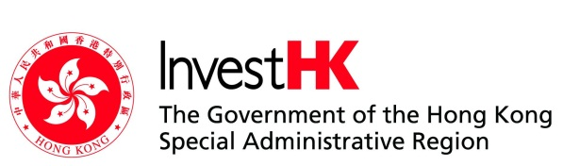
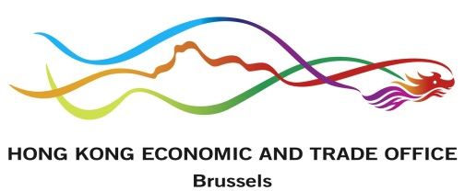
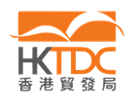

WORKSHOP: “Business Opportunities in Hong Kong”

organized by
SEV International Activities Activities
with the support of
Hong Kong Economic and Trade Office-Brussels
InvestHK
Hong Kong Trade Development Council HKTDC

Wednesday, March 18th, 2015 (15:00-18:00)
SEV Premises, 5 Xenofontos str., Athens

Registration
please send to: patsiavos@sev.org.gr

Company:

Activity:

Participant:

Position:

tel:

e-mail:

