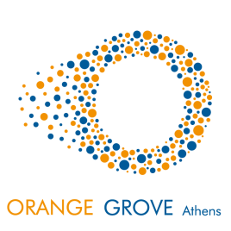

ORANGE GROVE

Are you under 35 years old and do you have a brilliant business idea, ready to be launched? Have you started a business and are you looking for a network of experienced professionals and mentors that will help you accelerate your business?

The Dutch Embassy in Greece, together with companies, universities and friends, initiates Orange Grove Athens, a new and unique co-working environment which will offer flexible working spaces to up to 70 young entrepreneurs and allow their innovative ideas to grow and thrive.

Orange Grove will be housed on the ground floor of the Embassy building, across from the Kallimarmaro Stadium, offering a wide network of contacts and the necessary expertise to young entrepreneurs who want to start or expand their activities in Greece.

For more news on Orange Grove Athens stay tuned to our channels on Facebook and LinkedIn. Interested in applying? E-mail us a scan of your ID to receive the application form which lists all the requirements (ath-og-applications@minbuza.nl).

Athenian Brewery, part of Heineken, is the main sponsor of Orange Grove. Co-sponsors are Interamerican, Philips, KLM and Coco-Mat. Other sponsors are currently finalizing their pledges. Many more companies will contribute in different ways and forms.

[*www.facebook.com/orangegroveathens*](http://www.facebook.com/orangegroveathens)

[*www.orangegrove.biz*](http://www.orangegrove.biz)