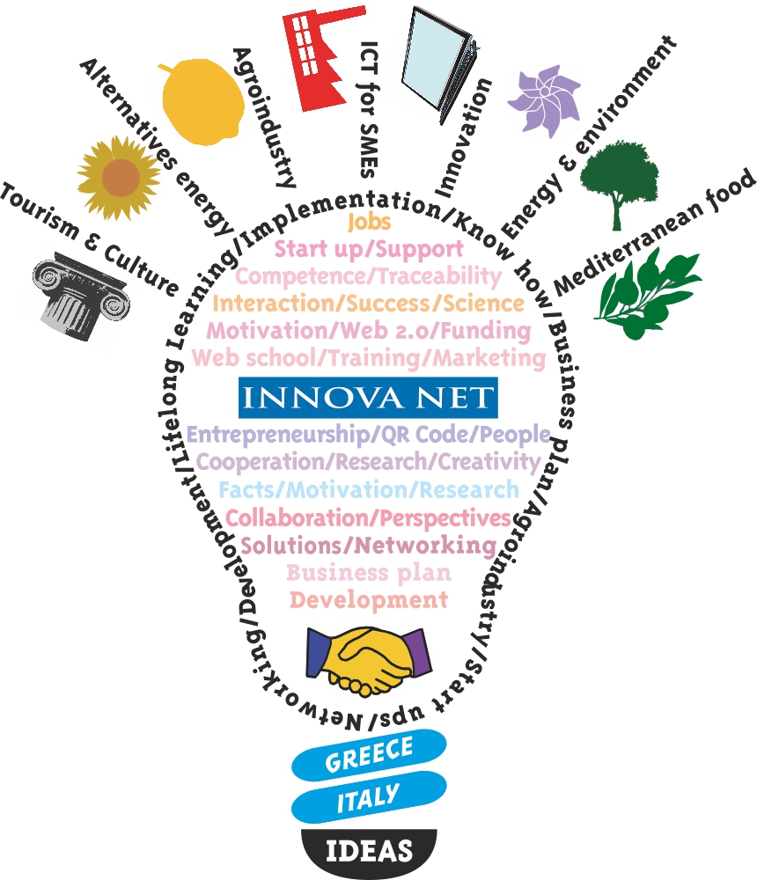

## INNOVA NET call for Applicants for the Entrepreneurial Webinars

**INNOVA NET announces the opening of 4 Entrepreneurial Webinars.**

Within the framework of the project **INNOVA NET – International Center of Competences for Innovation in the Mediterranean Countries**, funded by the European Territorial Cooperation Program Greece – Italy 2007-2013, the Technological Educational Institute of Epirus as the responsible partner of the Work Package (WP5) “TRIS: projects for innovative ideas and enterprises”,is organizing**,** under the umbrella of **INNOVA School of Competence**, 4 **Entrepreneurial Webinars**.

Applications to attend the Webinars are welcomed from:

* Executives of SMEs
* Employees of SMEs
* Owners/CEO of SMEs

The 4 **Entrepreneurial Webinars** will be conducted on line from INNOVA NET web site’s platform (<http://bbb.innova-net.eu>). The total duration of each webinar is 1 hr. and they will cover the following themes:

**Webinar 1:** What is innovation? Why should I innovate?

**Webinar 2:** Be updated!!! The role of ICT in SMEs’ development

**Webinar 3:** Clusters for business internationalization

**Webinar 4:** Self evaluating my SME prior to participation in investment proposals involving innovation

Anyone who is interested in applying to attend the **Webinars** should complete the **online registration form** via <http://www.innova-net.eu/form/entrepreneurial_webinars/> by **June** **30th, 2013**.

After the completion of the registration form, an email will be sent to you within 48 hours to confirm your registration and with the relative information to log in the project’s platform.

An email will be sent to you 24hrs prior the opening of the chosen webinar.

The webinars will be implemented from **July 1st 2013** until **July 10th 2013**.

For further information contact the following email address:

[form@innova-net.eu](mailto:form@innova-net.eu) or visit the project’s website: [www.innova-net.eu](http://www.innova-net.eu)

**Short description of the Webinars’ content**

Webinar 1: ***What is innovation? Why should I innovate?***

*"Innovation is the specific instrument of entrepreneurship. The act that endows resources with a new capacity to create wealth."*— Father of modern management Peter F. Drucker (1909-2005)

**The aim**

The aim of Webinar 1 is to make the participants understand the definition “innovation”, to become aware of the advantages and disadvantages of innovation, and the means to innovate in their business.

**Target group**

The beneficiaries of this seminar are entrepreneurs or SMEs’ employees who are willing to understand the commonly used term “innovation” and its usage in their SME.

**Short description of Webinar 1**

Definition of “innovation”

Innovation vs. invention

Types of Innovation

Criteria of innovation

Case Studies

**Trainer**

**Dr. Ioannis Bakouros**, *Assistant Professor, Department of Mechanical Engineering, University of Western Macedonia*

Webinar 2: **Be updated!!! The role of ICT in SMEs’ development**

*“Information technology and business are becoming inextricably interwoven. I don't think anybody can talk meaningfully about one without the talking about the other.”-* Bill Gates

**The aim**

The aim of Webinar 2 is to inform entrepreneurs about the advantages of the use of ICT in a business and to present new smart tools that are considered new solutions for SMEs’ development.

**Target group**

This Webinar is targeted to entrepreneurs who are involved in ICT development as well as businessmen who work with ICT tools and want to improve their business productivity and evolve in the new market.

**Short description of Webinar 2**

1. Why use ICT tools in your SMEs?
2. What is their role and impact in SMEs?
3. Case studies
4. New tools of ICT for SMEs

**Trainer**

**Dr. George Manis**, *Assistant Professor, Dep. of Computer Science & Engineering, University of Ioannina*

Webinar 3: ***Clusters for business internationalization***

“*Don't put anything up there that is too small. Do clusters or groupings." - Heidi Johnson*

**The aim**

The aim of Webinar 3: Clusters for business internationalization, is to introduce to entrepreneurs the concept of clustering as tool of development and to present them a new way to lead the markets by collaborating with their competitors and others.

**Target group**

This webinars will appeal to entrepreneurs who are looking for acquiring a new way out to the markets by alternating the organizational structure and changing the way they think about their competitors.

**Short description of Webinar 3**

1. What is a cluster?
2. Grouping or clustering
3. The importance of internationalization to sme's
4. The role of clusters in going international
5. Case studies

**Trainer**

**Dr. Ioannis Bakouros**, *Assistant Professor, Department of Mechanical Engineering, University of Western Macedonia*

Webinar 4: **Self evaluating my SME prior to participation in investment proposals involving innovation.**

*“If you know the enemy and you know yourself, you need not fear the results of a hundred battles.” – Sun Tzu C. 544-496 BC, Military Strategist and Author of The Art of War*

**The aim**

The aim of this webinar is to present the Benchmarking analysis as a tool of self-evaluating an SME so as to see the weakness and strengths.

**Target group**

This webinar aims to stimulate entrepreneurs to conduct a self-evaluation in order to highlight their competitive advantages and disadvantages and become more competitive.

**Short description of Webinar 4**

1. What is benchmarking analysis?
2. What will I gain from the benchmarking analysis?
3. What does it measure?
4. How can I conduct a benchmarking analysis?

This self–evaluation webinar has been designed with simplicity in mind, as a basic requirement of audience. The wizard allows consideration to the following points:

* The characteristics of the proposed innovation that can be a benefit to the individual SME’s competitiveness.
* The key points of the proposed innovation that can be associated with risks for SMEs.
* The ability of SMEs to integrate innovative proposals.
* The impact of the proposed innovation (investment) in the economic performance of SMEs.
* The comparative "value" for the company, two or more alternative investment proposals (with some restrictions).

**Trainer**

**Dr. Ioanna Giannoukou**, *Financial Manager – Researcher, University of Patras*

**A few words about INNOVA NET project**

INNOVA NET project stems from the previous experience of partners and from feasibility studies on the creation of a school as part of transnational innovation produced through the INNOVA project, funded by [INTERREG Greece-Italy 2000-2006](http://3kps.interreg.gr/default.aspx?lang=en-GB&loc=1&page=306).

The Italian and Greek territories considered in the project ([Province of Bari](http://www.provincia.ba.it/), [Prefecture of Achaia](http://www.pde.gov.gr/gr/), [Prefecture of Ilia](http://www.pde.gov.gr/gr/), [and Prefecture of Arta](http://www.peartas.gov.gr/)) present a relatively similar socioeconomic background.

At present, enabling existing or potential SMEs to create business opportunities and create new jobs requires increases in innovation and technology transfer developed alongside universities and research centers.

The INNOVA NET project will thus form a stable network between universities, research institutes, companies and local institutions in the territories involved, through the consolidation of skills in 4 key areas, vital to local development in both Italy and Greece. Such a relationship should develop with the needs of companies and the entire economic and social structure at its base, supported by innovative projects allowing for solutions to institutional problems through a participatory approach to Greek and Italian organizations, institutions and businesses.

The geographical location and the presence of a great historical/cultural background give the Greek and Italian territories involved in the project a great economic potential.

In the INNOVA NET project have been identified 4 economic areas of great strategic importance for the socio-economic development of both countries and treated as centers for developing of competences; in particular these are: Energy & Environment, Cultural Heritage & Tourism, ICT for SMEs and Agribusiness & Mediterranean food diet.

With a view to developing skills in these areas, the INNOVA NET project, through a transnational approach and joint action by universities, research centers, SMEs and public authorities, aims to strengthen the competitiveness and accelerate the process of internationalization of companies that operate in economic fields identified.